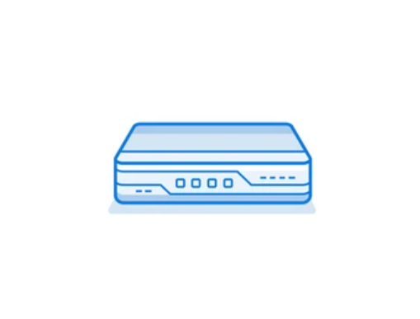

Creating a SOHO Configuration

Evan Choi | Cisco Cybersecurity | 10/20/2022

**Purpose**

The purpose of this lab is to understand how to create a SOHO network by configuring a LAN and WAN interface so you can connect to the internet via firewall.

**Background Information on lab concepts**

A SOHO network stands for Small Office/Home Office network, and they are essentially small LANs. They usually consist of less than 10 computers and are meant to be used by small businesses. Similar to other LANs, they are made up of wireless and wired computers. Their main purpose is to connect multiple computing devices on a single network so they can share information effectively with other connected users in their organization.

When creating a SOHO network, you need to configure your firewall so it can access the internet, and you also need to access the management web GUI so you can configure policies and zones.

A security zone is a way to group physical and virtual interfaces on a firewall so you can control and log the traffic that goes through certain interfaces on your network. Interfaces on a firewall must be assigned to a security zone before it can process traffic. Zones can be assigned multiple interfaces of the same type (layer2, layer 3, or tap interfaces), but an interface can only belong to a single zone. To create a security zone you need to name the zone, assign interfaces to the new zone create, and more. There are four main types of zones that you can use:

* **Tap Zone:** Used with SPAN/RSPAN, allowing you to monitor traffic
* **Virtual Wire:** Used to bind two interfaces within a firewall (also known as Transparent Firewall)
* **Layer 2:** Used when switching between two or more networks
* **Layer 3:** Used when routing between two or more networks.

A Security Policy is a key element of cybersecurity. They are used to determine whether to block or allow the session based on specific attributes on incoming traffic. These attributes can be the source and destination Security Zone, the source and destination IP address, the application, the user, and the service. The firewall will match all passing traffic against a session, and each session will be matched against a Security Policy rule. Once a session match happens, the bidirectional traffic in that session will be applied to the corresponding Security Policy rule. If traffic doesn’t match any already defined rules, the default rules will be applied. The default rules are predefined, allowing all intrazone traffic and denying all interzone traffic. However, you can override these rules and change some settings such as tags, action, log settings, and Security Profiles.

A Security Profile is an addition to Security Policies. When traffic is allowed by the Security Policy, the Security Profile helps you define an **allow but scan** rule, scanning allowed application for threats including viruses, malware, spyware, and DDOS attacks. Traffic matching the allow rule that’s defined in the Security Policy will have the corresponding Security Profile applied for further content inspection rules like antivirus checks and data filtering. Multiple Security Profiles can be combined to create a Security Profile group which can be treated as a unit and added to Security Policies in a single step.

**Lab Summary**

In this lab, I used a Palo Alto PA220 firewall and 3 ethernet cables to connect the firewall to internet and jumper the management port to LAN. After accessing the web GUI, I created Security Zones and a VLAN object, configured a VLAN Interface, DHCP Server, Outbound Internet Security Policy, Outbound Internet NAT Policy, and MGMT IP. Finally, I commit changes to save all my configurations.

**Network Diagram**

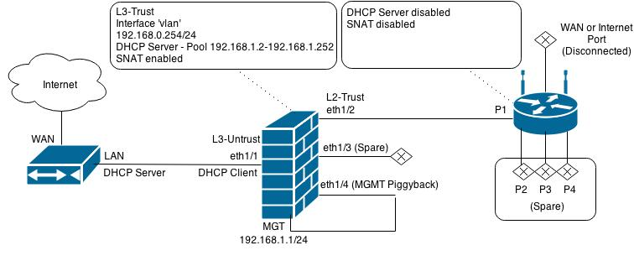

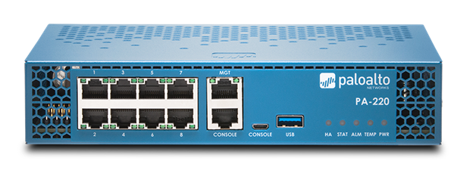



**Procedure**

1. Connect a **Console cable** to the **Console** port on the palo alto
2. Configure the Ethernet port of your computer to have an IP address of 192.168.1.2 and a netmask of 255.255.255.0.
3. Open a **web browser** (preferably Firefox) and type[**https://192.168.1.1**](https://192.168.1.1)**.** A web GUI like the one below should appear. The default credentials are: username: admin, and password: admin, but they may be changed to the username and password you set in the factory reset lab.

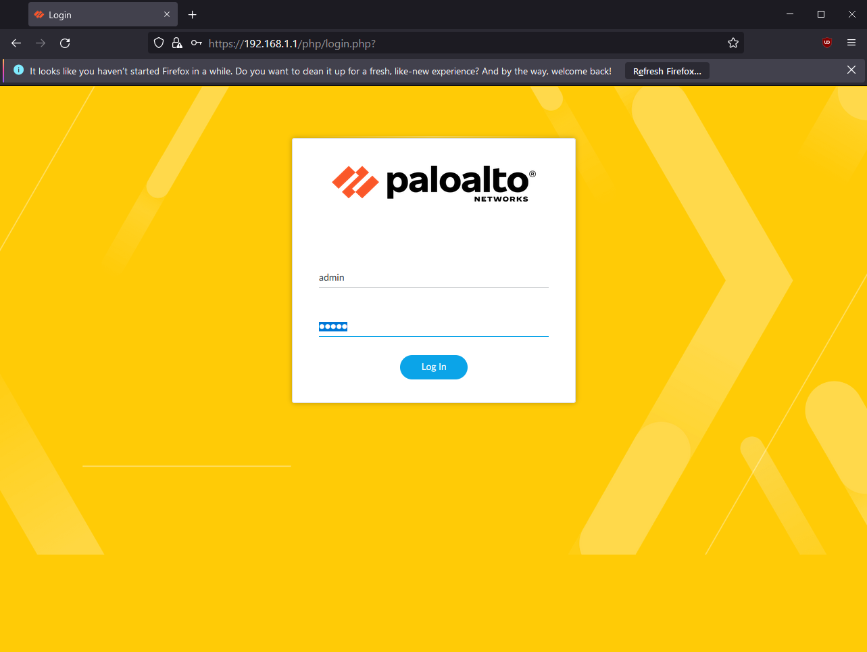

1. After logging in, the following dashboard should appear. At the very top, press the **Network** tab then click **Zones.**

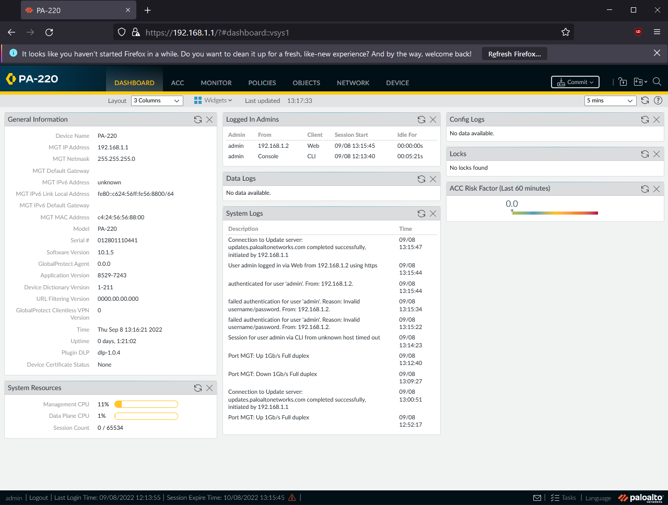

1. Click the **Add** button, and create the following 3 zones:

* Name: Untrust-L3, Type: Layer 3
* Name: Trust-L3, Type: Layer 3
* Name: Trust-L2, Type: Layer 2

You should end up with something like this:

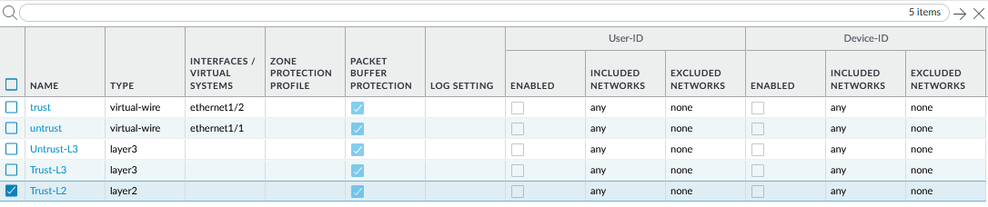

1. Now, connect a **UTP cable** from your ISP modem to your Palo Alto firewall, through **ethernet1/1.**
2. Go to the **Network** tab, and press **Interfaces.** Configure **ethernet 1/1** with the following:

* Interface Type: Layer 3
* Virtual Router: default
* Security Zone: Untrust-L3

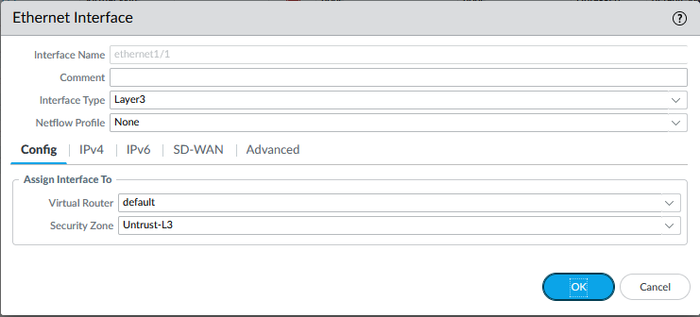

1. Still under **ethernet 1/1,** go to the **IPv4** tab and set the Type to **DHCP Client.** There should be a check mark next to **Enable** and a check mark next to **Automatically create default route pointing to default gateway provided by server.** It should look like the image below.

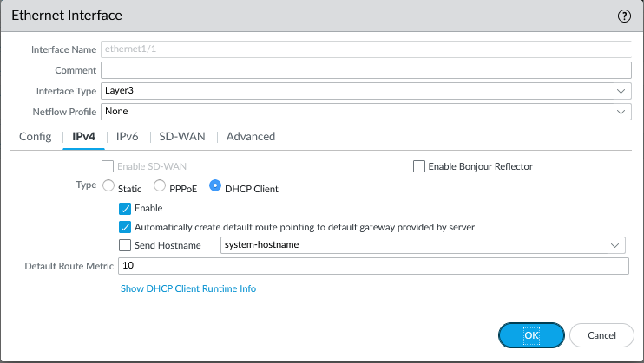

1. Now you will create a VLAN Object. Go to the **Network** tab and click **VLANs.** Click **add.** Enter a name and select **vlan** for the VLAN Interface. I named mine **Vlan Object.**

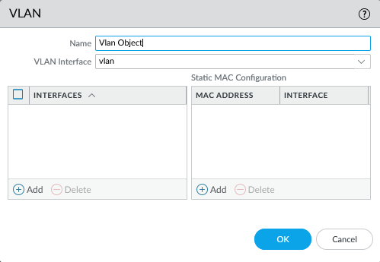

1. Now you will configure the Layer2 Ports and VLAN Object. Go to the **Network** tab, then click **Interfaces**, then click **Ethernet.** For the ethernet1/2, ethernet1/3, and ethernet1/4 interfaces, change the settings to the following:

* Interface Type: Layer2
* Netflow Profile: None
* VLAN: VLAN Object
* Security Zone: Trust-L2

It should look like the following, for each of the respective ethernet ports

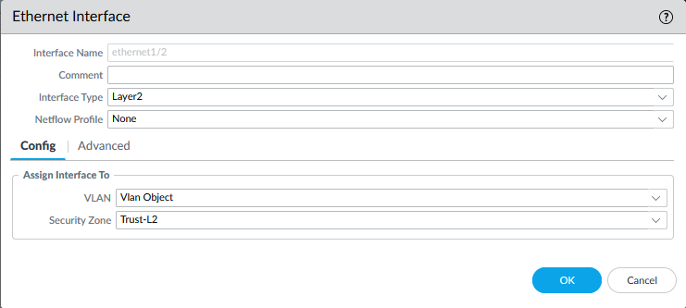

1. Now you will configure the VLAN interface. Go to the **Network** tab, click **Interfaces,** then click **VLAN.** In the **Config** tab, configure the following:

* VLAN: VLAN Object
* Virtual Router: default
* Security Zone: Trust-L3

Also, put a **10** in the box on the top right.

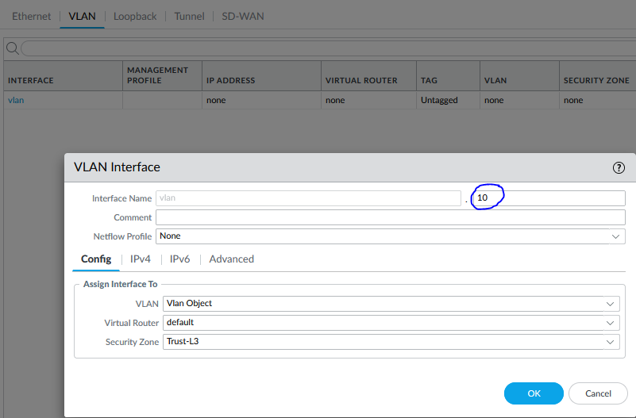

1. Now, go to the **IPv4** tab, click the **Add** button in the bottom left, and enter the IP address, 192.168.1.254/24. Click **Ok.**

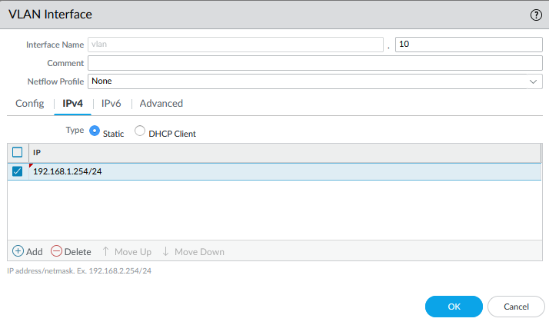

1. Now you will configure a DHCP server. Go to the **Network** tab, click **DHCP,** then click **DHCP Server.** Edit the settings to look like the image below.

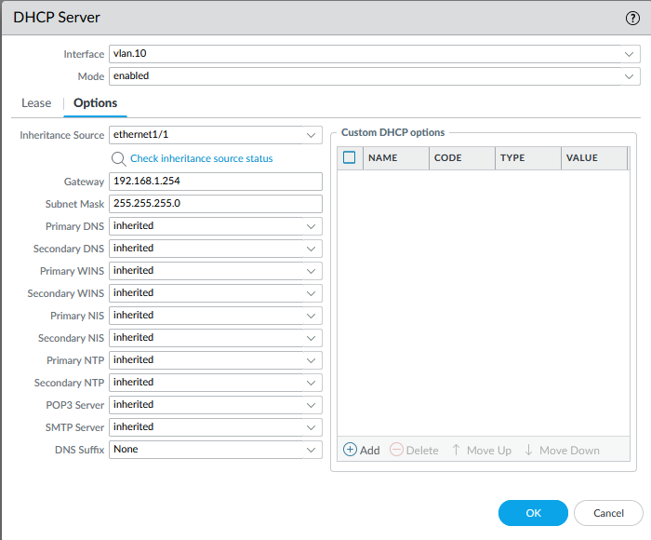

1. Under the **Lease** tab, configure the following:

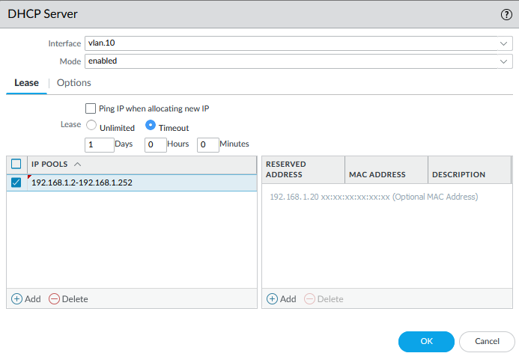

1. Now you will define a security profile group. Go to the **Objects** tab and click **Security Profile Groups.** Click **Add.** Change the settings to the following:

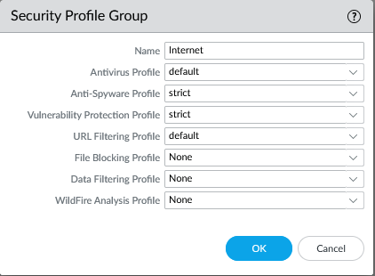

1. To the configure the Outbound Internet Security Policy, go to the **Policies** tab, and click **Security.** Click **Add.** Enter a **Name** and **Description** like shown below:

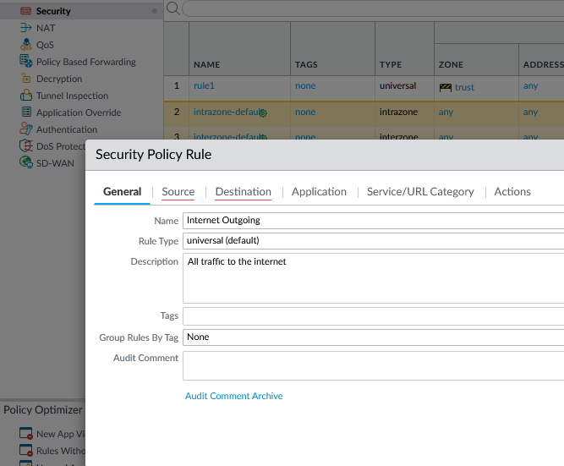

1. Go to the **Source** tab and add **Untrust-L3** to the Source Zone and under the **Destination** tab and add **Untrust-L3** to the Destination Zone.

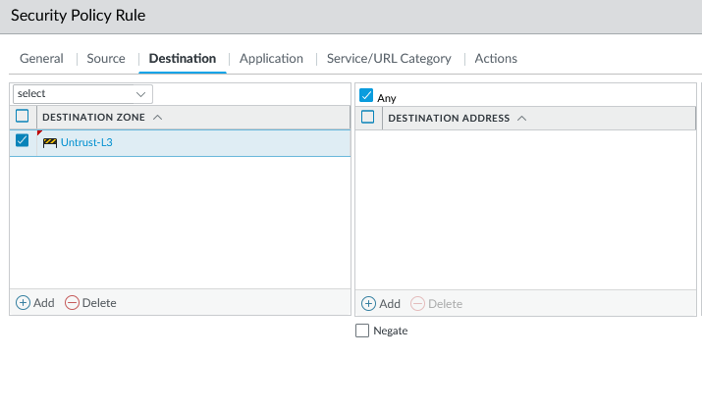

1. Go to the **Actions** tab and change the settings to match the following image:

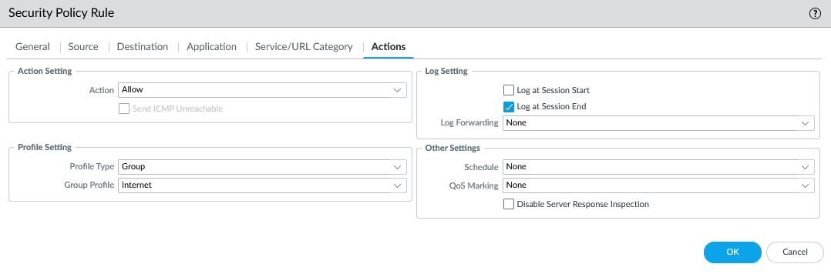

1. You will now configure the Outbound Internet NAT Policy. Go to the **Policies** tab and click **NAT.** Click the **Add** button and enter a name and select IPv4.

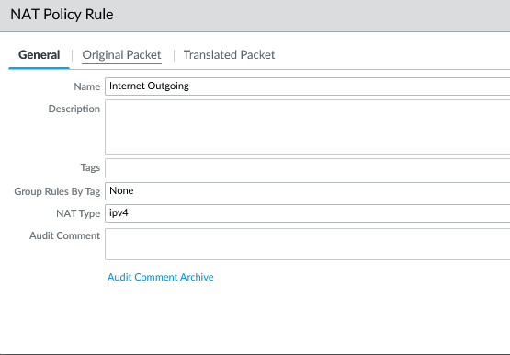

1. Go to the **Original Packet** tab and specify the **Source Zone, Destination Zone,** and **Destination Interface.**

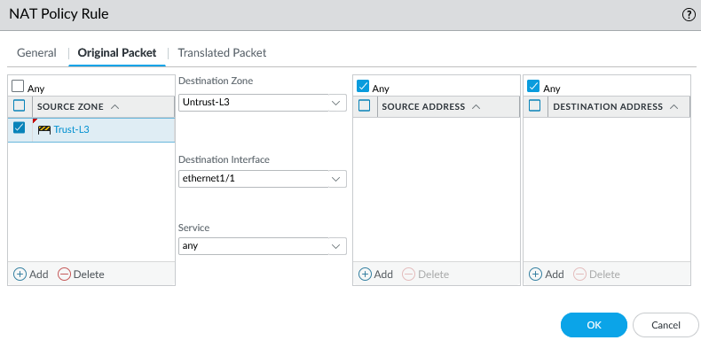

1. Go to the **Translated Packet** tab and edit the following:

* Translation Type: Dynamic IP And Port
* Address Type: Interface Address
* Interface: ethernet1/1

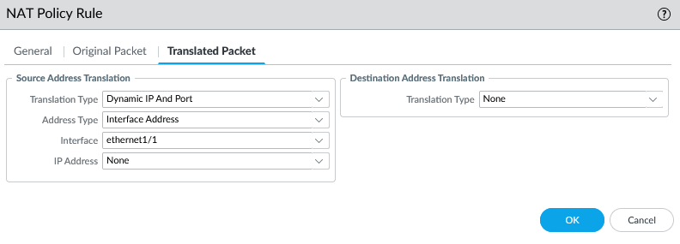

1. Now you will configure the MGMT IP. Go to the **Device** tab, click **Setup,** and click **Management.** Configure the IP Address, Netmask, and Default Gateway.

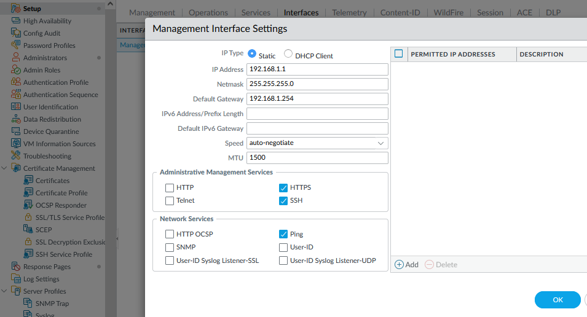

1. Now, you will delete the default-vwire. Go to the **Network** tab, click **Virtual Wires,** and click delete on **default-vwire.**

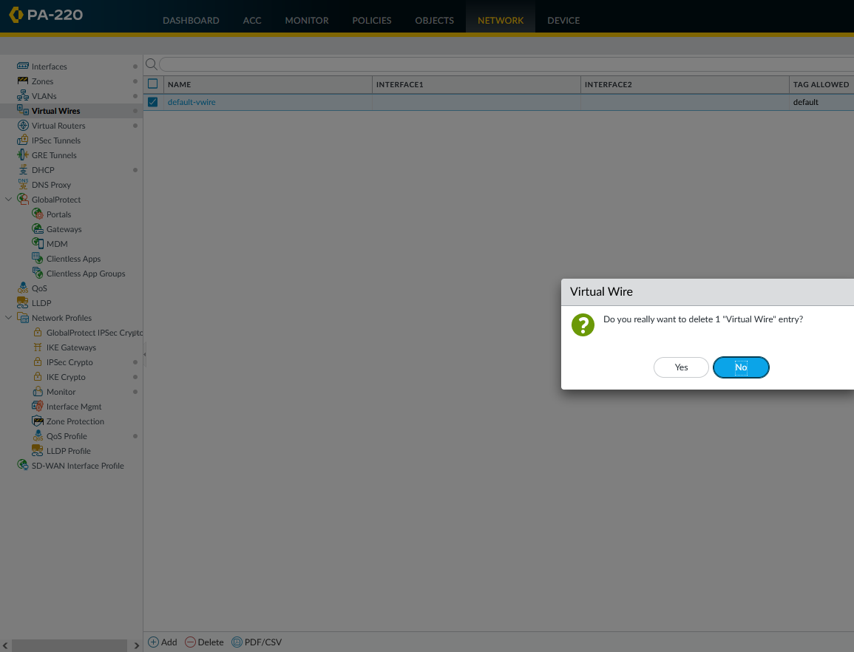

1. To save all your changes, at the very top, press the **Commit changes button.** A message like this should appear if successful.

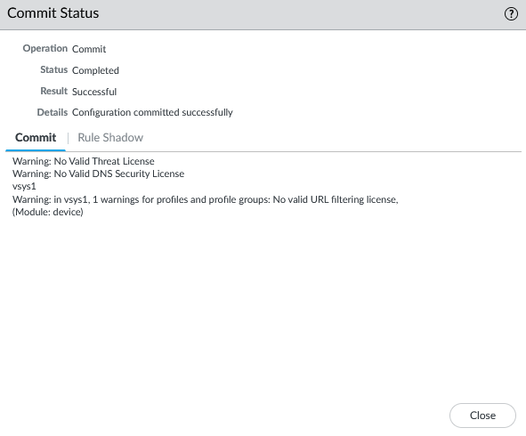

**Problems**

A problem I faced during this lab was committing changes. When attempting to commit changes I got a message saying, “virtual wire default-vwire is missing on one or more interfaces,” preventing me from commit changes. Under result, it said that the Commit Status had failed, meaning none of my configurations were saved.

Since the message mentioned the virtual wire, I decided to look at that first. After looking and asking my peers, I figured out that I had to delete the default-vwire. While talking to them I also found out that I had to change the Source and Destination Policy Rule to Untrust L-3. After making these changes, I commit changes and it was successful.

**Conclusion**

A SOHO network is a small LAN that connects multiple computing devices on a single network so they can share information effectively with other connected users in their organization. While configuring a SOHO network, you will have to create Security Zones, and configure Security Policies and Security Profiles. You will also have to create a VLAN object, configure a VLAN interface, and configure a DHCP Server. Although I was having problems committing changes on the web gui, I was able to eventually figure out how to commit changes successfully, allowing me to complete the lab. Through this lab I learned how to create a SOHO network as well as understanding how certain aspects of a SOHO configuration work.

**Teacher Signoff Page of Lab Completed**

The stamp below recognizes that

Evan Choi

has completed

**Lab 2 – Firewall SOHO Setup**

 Adv Cisco Cybersecurity – Mr. Mason & Mr. Hansen

Period 5